IFG Explore Egg-speriments
3rd Year
2nd Term, Week Six Interest
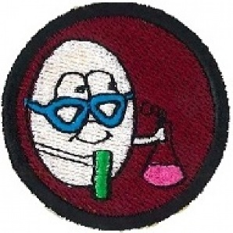
Aim: To learn about eggs and do egg-speriments.

Objectives:
- To share information about eggs
- Try some egg-speriments
- Make a pom pom chicken

Equipment & Preparation:
- Eggs for egg-speriments and relevant equipment
- Cardboard and wool for pom pom chickens

Pre SetUp:
- Organise some games for when the girls start to arrive
- Set tables up and put out equipment

Set Up:
Usual set up and roll call.

Devotions:
Eggs:
Staying with relations on a farm in the country I noted they had quite a collection of animals, as well as the usual farm animals, they had chickens, ducks, geese, turkey’s and emu’s. While I was there, my responsibility each day was to feed the birds and collect the eggs. I noticed that the chickens laid brown, green, blue and white eggs (strange colours but that is true). The turkeys eggs were larger than the chickens and were white with brown specks. The ducks eggs were even larger, then the geese eggs, with the largest ones being from the emu.
Every morning we would check the nests and while we were doing so there were always a few that would sing out. On some days we would have lots of eggs and on others all the birds seemed to go on strike. Each type of bird laid an egg that was unique to them and no amount of encouragement would make them lay a different egg.
As Christians, you might also say we each have our own eggs. We also have our own unique contributions to make to the family of God:
Some people are easily eggcitable. Others tend toward eggsaggeration. Some are gifted in eggsplanations of God's word. Some set great eggsamples. Some seem eggsellent at almost everything they do. Some are gifted with eggcitement, or eggsperience in many different areas.
Of course there are always a few rotten eggs. Those who have unrealistic eggspectations, eggsclude others, and eggsploit people. There are those who are always making eggcuses and always focusing on eggsternal things.
Jesus said you can tell a tree by its fruit. But you can also tell a bird by its eggs.
Just remember you don't have to be an eggspert to eggsercise your gifts in your family or in your life.

Teaching Session:
Where do the eggs we eat come from? Eggs come from poultry including chickens, ducks, geese, turkeys; emu’s and quail although chicken eggs are the ones most widely used.
Why we need eggs – they provide protein and other nutrients our bodies need.
What are eggs used for? Besides eating eggs fried, boiled, scrambled and many other ways, eggs are used for a variety of dishes, in cakes etc.
Some interesting facts about eggs:
- A hen requires 24 to 26 hours to produce an egg. 30 minutes later, she starts all over again.
- A hen can lay between 250 and 270 eggs per year (compare this to 365 days in a year)
- The eggshell may have as many as 17,000 tiny pores over its surface. Through them, the egg can absorb flavours and odours.
- Eggs age more in one day at room temperature than in one week in the refrigerator.
- Hens with white feathers and ear lobes produce white shelled eggs. Hens with red or brown feathers and red ear lobes produce brown shelled eggs.
- If an egg is accidentally dropped on the floor, sprinkle it heavily with salt for easy clean up.
- Egg yolks are one of the few foods that naturally contain Vitamin D.
- Yolk colour depends on the diet of the hen. Natural yellow-orange substances such as marigold petals may be added to light-colored feeds to enhance colours. Artificial colour additives are not permitted.
- Eggs are nutritious for many pets as well as humans and are often an important part of prepared pet food formulas. Eggs can improve animal fur and coat health and maintain eyesight.
- A pullet is a ‘young’ hen (like a heifer is a ‘young’ cow)
- Shell thickness is related to egg size, which, in turn, is related to the hen's age. As the hen ages, egg size increases. The same amount of shell material which covers a smaller egg must be ‘stretched’ to cover a larger one, hence the shell is thinner.
- Eggs are an important source of complete protein for vegetarians. One egg = 1 ounce of lean meat, fish or poultry.
- China produces the most eggs in the world, at about 160 billion per year.
- In the United States of America, about 260 million hens produce more than 65 billion eggs per year.
- The chicken was one of the first domestic animals, appearing in China around 1400 BC.
- The world’s smallest egg is from a hummingbird.
- World’s largest egg is an ostrich egg. An ostrich egg needs to be boiled for 2 hours to get a hard-boiled egg.

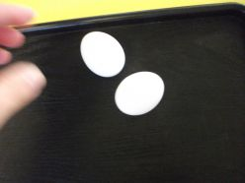
Activitiy 1:
Here are two egg-speriments for you to share with your girls.
Spinning Around
Materials:
1 hard-boiled egg
1 raw egg
Ever wondered how you can tell the difference between a hard-boiled egg and a raw egg?
Just spin them to figure it out. Place a hard-boiled egg and a raw egg on the table.
Spin each of them and observe what happens. The boiled egg will spin faster. The raw egg will spin slowly. The reason for this has to do with the insides. The boiled egg is one solid piece. Therefore the whole egg spins in the same direction. The raw egg has liquid inside which moves separately from the shell. The movement of the inside of the raw egg keeps the whole egg from spinning quickly. Observe what happens when you try to stop the spinning of the eggs. Spin the eggs and then put your finger on them to stop them. The boiled egg should stop immediately. The raw egg will keep spinning for a moment because the liquid inside the egg will keep moving.

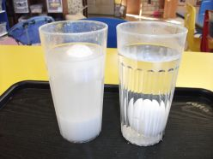
Floating eggs in salt water.
In this experiment you will demonstrate the principles of density, mass and weight by floating an egg in saltwater. To Sink or to Float
Materials:
Salt Tablespoon
2 clear glasses Warm water
2 raw eggs
Will an egg sink or float in normal water? What effect will salt have? Place the two glasses of warm water on a table. Add about 10 heaped tablespoons of salt to one of the glasses and stir until the salt is dissolved in the water.
Place an egg in each glass and observe what happens. The egg in the normal water will sink to the bottom while the egg in the salt water will float to the top.
Expand on the experiment by mixing the two types of water. Remove the eggs from the glasses. Empty about half of the salt water. Then pour the plain water into the salt water cup up to the amount the glass had before. Place the egg in the cup. The egg will float in the middle of the cup.
Make the egg rise to the top again by removing the normal water. With the egg still in the glass, begin slowly removing the water a spoonful at a time. The egg will rise higher and higher as each spoonful is removed.
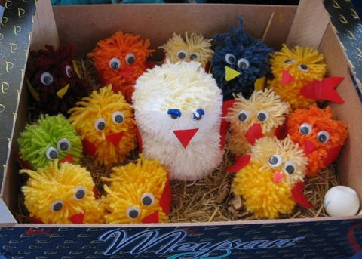
The egg floats in salt water because of density. Salt water is denser than the egg thereby causing the egg to rise to the top. The egg is denser than normal water, though, which is why it sinks to the bottom when in the cup of normal water.

Activity 2:
Make a pom pom chicken:
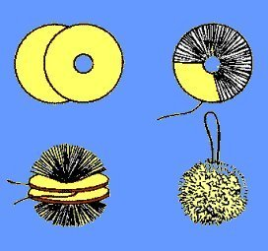
To make a pom-pom chicken, cut two circles of cardboard, the diameter depends on the size of the pom-pom to be made, and should be equal to the size of the finished pom-pom plus approximately 1cm for trimming, plus the diameter of the centre hole. eg: For a pom-pom 4cm across, the circles would be 4 cm plus 1cm plus 1cm for centre hole, equals 6cm. Cut a round hole in the centre; the size of the hole is approximately a quarter of the finished pom-pom. Wind the wool round and round the cardboard until the centre hole is completely filled up.
Place the point of the pair of scissors between the two pieces of cardboard and cut around, keeping scissors between two circles of cardboard all the time. Using a double strand of wool, wrap round between the two circles of cardboard, knot firmly, and take away cardboard - see diagram. Trim pom-pom
Add eyes and features to the pom pom to make a chicken.

Closing prayer
Home time & Notices

